**Room N-1 Specials**

Day 1 QUEST

1:20-2:00

j0237943

Day 2 Music

1:20-2:00

j0199228Day 3 Library 1:20-2:00

j0186172

Day 4 Gym

1:20-2:00

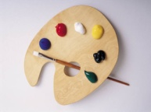Day 5 Art 2:10-2:50